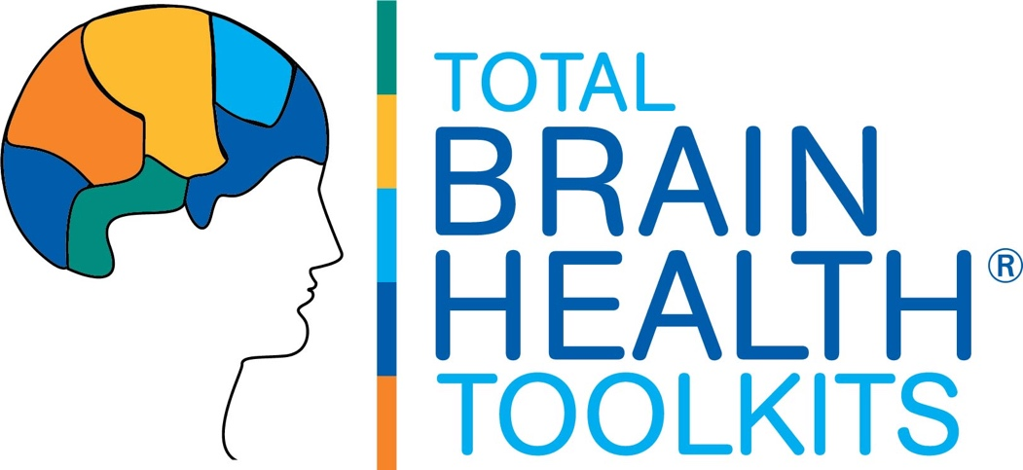

TBH FLEX 1.0 COURSE
SAMPLE PRESS RELEASE

Use the sample press release below as a guide to your own announcements of the TBH FLEX 1.0 Course to the local press, for your newsletter, blog, or other outlets.

(YOUR LOCATION NAME) TO HOST BRAIN FITNESS PROGRAM FOR THOSE LIVING WITH DEMENTIA
Expert-Designed Training Teaches Proven Ways to Maintain Thinking Skills,
Promote Well-Being for Those with Mild Memory Loss

(Location City/State, Date). The latest science shows that for those of us living with mild to moderate memory loss, engaging across our body, mind and spirit to can better support daily cognitive fitness and promote well-being.

This (time frame), (your location name) will host a series of brain wellness classes for those living with memory loss. Developed by leading brain wellness experts at Total Brain Health, the TBH FLEX course teaches the many different ways we can take care of our brains to live well and stay engaged across all levels of cognitive abilities. The TBH FLEX course will run from (date frame on your calendar) and is open to all (residents/community members/family/anyone).

Participants in this course will learn the science of whole-person wellness for maintaining everything thinking skills and promoting overall well-being. Class activities will include the practice of multi-sensory workouts that support brain healthy living activities, such as aerobic exercise, attentional skills and stress reduction.

(Trainer Name and Title) will be the course leader. “We are looking forward to offering the TBH FLEX course at (Campus Name). These brain training classes for people facing memory challenges reflect (Campus Name ‘s) ongoing effort to better educate our community on effective brain wellness interventions,” said (Name), (Title) of (Campus Name).

The TBH FLEX 1.0 course is one in a series of TBH Toolkits developed by brain health expert and author, Dr. Cynthia Green. “At Total Brain Health, we believe that all minds can thrive. The tools we develop help everyone get smarter about their brain health. Our programs give everyone valuable information they can use to stay vital in mind, body and spirit, regardless of where they are on the cognitive continuum,” says Dr. Green. “Our programs offer scientifically-based brain fitness training that empower everyone to build better brain health.”

All classes will be held at (Campus Name and Address) from (dates and times). To register, please call (phone number) or email (email address).

To learn more or register for the program, call (phone number) or email (email address).
___________

About Total Brain Health. At Total Brain Health, we believe that all minds can thrive. As leading experts in cognitive fitness, we deliver tools everyone can use to build better brain health, no matter their age or ability. Backed by three decades of research, our training programs teach effective steps to boost brainpower and improve cognitive vitality using highly social, fun and engaging workouts. Products include our TBH Toolkits, social-based brain training for groups, and TBH Toolbox365, a daily cognitive training solution for individuals and one-to-one use.

About (your location name). (Company information and logo).
GET THE WORD OUT! TOOLKIT RESOURCES

TBH FLEX 1.0 OUTREACH PACKET

- Sample Press Release

- Sample Newsletter Announcement

- Total Brain Health Logos

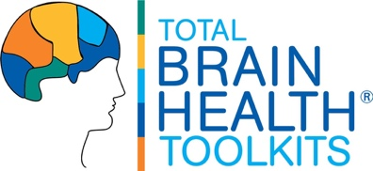
TBH FLEX 1.0 COURSE
SAMPLE PRESS RELEASE

Use the sample press release below as a guide to your own announcements of the TBH FLEX 1.0 Course to the local press, for your newsletter, blog, or other outlets.

(LOCATION NAME) TO HOST BRAIN FITNESS PROGRAM FOR THOSE LIVING WITH DEMENTIA
Expert-Designed Training Teaches Proven Ways to Promote Well-Being When Living with Mild Memory Loss

(Location City/State, Date). The latest science shows that for those of us living with mild to moderate memory loss, engaging across our body, mind and spirit can better support daily cognitive fitness and promote well-being.

This (time frame), (your location name) will host a series of brain wellness classes for those living with mild memory challenge. The TBH FLEX course will run from (date frame on your calendar) and is open to all (residents/community members/family/anyone).

Developed by leading brain wellness experts at Total Brain Health, the FLEX program is a state-of-the-science cognitive training series uniquely designed for individuals with early-stage cognitive challenge. The program brings attendees robust, engaging workouts that target thinking skills, bolster communication, and promote healthy living for those living with mild memory loss.

(Trainer Name and Title) will be the course leader. “We are looking forward to offering the TBH FLEX course at (your location name). These brain training classes for people facing memory challenges reflect (your location name’s) ongoing effort to better educate our community on effective brain wellness interventions,” says (name), (title) of (your location name).

The TBH FLEX 1.0 course is one in a series of TBH Toolkits offered by Total Brain Health. “At Total Brain Health, we believe that all minds can thrive. Our programs give everyone valuable information they can use to stay sharp and vital intellectually, physically and socially, regardless of where they are on the cognitive continuum,” says Dr. Green. “Our programs offer scientifically-based brain fitness training that empower everyone to build better brain health.”

All classes will be held at (location name and address) from (dates and times). To register, please call (phone number) or email (email address).
___________

About Total Brain Health. Dedicated to helping all minds thrive, Total Brain Health empowers adults 50+ with scientifically grounded brain fitness programs. Established in 2015, we deliver powerful interventions for cognitive training, social connection, and healthy aging for small group and individual use. Learn more at totalbrainhealth.com.

About (your location name). (Company information and logo).

TBH FLEX 1.0 PROGRAM
SAMPLE NEWSLETTER ANNOUNCEMENT

Use the sample copy below as a guide to your own announcement for internal outlets such as a community newsletter, calendar, e-portal or other communications.

LIVING WITH MILD MEMORY LOSS?

JOIN THE TOTAL BRAIN HEALTH FLEX CLASS!

Come join us as we “get smarter” about brain health! Developed by the leading brain fitness experts at Total Brain Health, the TBH FLEX 1.0 course teaches the many proven ways we can support our thinking and promote overall well-being when living with mild memory changes.

You will:

- Discover how lifestyle changes can support our thinking and promote healthy living when managing mild memory loss.

- Train with hands-on workouts that bring the science home to you -- right in the classroom.

- Have fun with your classmates as you learn to care for your brain health, together!

Our TBH FLEX 1.0 classes will meet (day) at (times) in the (location).

For more information, contact (name) at (contact information).

TBH FLEX 1.0 COURSE
TOTAL BRAIN HEALTH LOGOS

Permission is provided to use the Total Brain Health logos below to identify the course and/or to promote your affiliation with Total Brain Health. For all other permitted uses contact us at info@totalbrainhealth.com.

Please note that Total Brain Health© and TBH© within the use of educational materials are trademarked to Total Brain Health, with all rights reserved.

TBH LOGO DESCRIPTION | LOGO (JPEG)
TOTAL BRAIN HEALTH© LOGO | 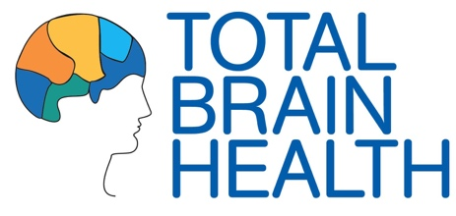
TOTAL BRAIN HEALTH© LOGO WITH WELLNESS BRANDING | 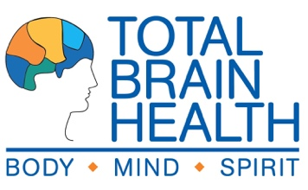
TBH© TOOLKITS LOGO (GENERAL) | 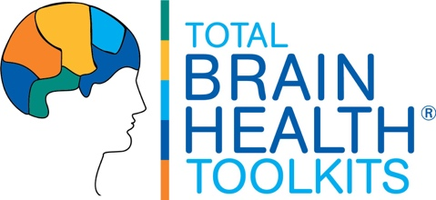
TBH© FLEX 1.O LOGO | 