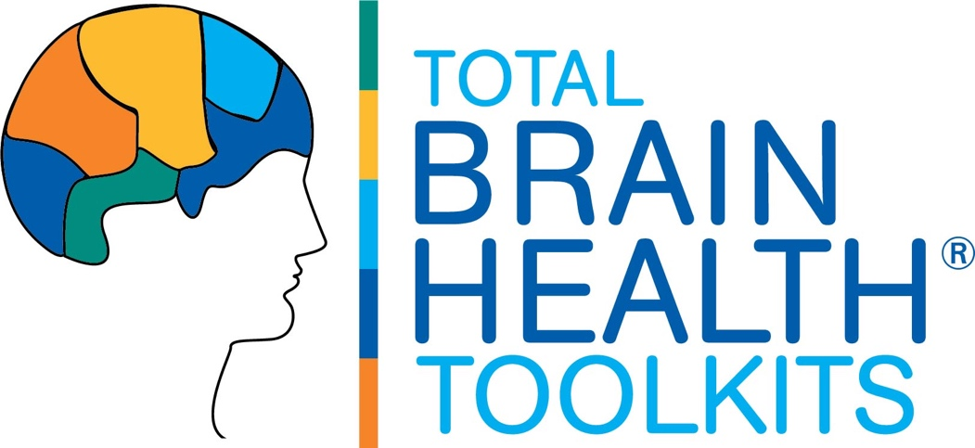­

***GET THE WORD OUT!* TOOLKIT RESOURCES**

**TBH BRAIN WORKOUT 2.0 OUTREACH PACKET**

* Sample Press Release
* Sample Newsletter Announcement
* TBH Toolkits Description
* Total Brain Health Logos



**TBH BRAIN WORKOUT 2.0 COURSE**

**SAMPLE PRESS RELEASE**

*Use the sample press release below as a guide to your own announcements of the TBH BRAIN WORKOUT 2.0 Course to the local press, for your newsletter, blog, or other outlets.*

**(YOUR LOCATION NAME) TO HOST BRAIN WELLNESS PROGRAM**

***Expert-Designed Training Teaches Proven Ways to Boost Thinking, Reduce Dementia Risk***

*(Location City/State, Date).*  Maintaining brain health is top of mind, especially for those over 50. Yet few are aware of the cutting-edge research around lifestyle and social engagement on cognitive wellbeing. To help support cognitive performance in our community and reduce risk of decline, (*your location name*) will host a series of brain training classes developed by Total Brain Health (TBH).

This *(time frame), (your location name)* will offer a program that teaches hands-on ways participants can bring the latest brain fitness science to their daily routine. The Total Brain Health Brain Workout 2.0 course will run from (*date frame on your calendar)* and is open to all *(residents/community members/family/anyone)*.

Developed by the experts at Total Brain Health, the TBH BRAIN WORKOUT 2.0 course builds on the success of the original TBH BRAIN WORKOUT 1.0 coaching program through the addition of new brain workouts and increased class challenges that teach the many different ways we can use our lifestyle to boost cognitive brain wellness. With highly social, engaging and fun workouts across the pillars of physical, intellectual and socio-emotional well-being, students learn together how things such as following a Mediterranean-styled diet, thinking fast against the clock, juggling and de-stressing can boost brainpower.

“We look forward to offering this Total Brain Health course at *(your location name).* The Brain Workout classes reflect our commitment to bringing our community the very best programs to promote well-being, including cognitive wellness, which is so central to healthy aging and of such great concern to so many” said *(Name, Title)* of *(your location name).*

As leaders in the field of cognitive fitness, Total Brain Health uses a proprietary training approach that teaches brain-building lifestyle interventions using robust social engagement and hands-on learning. “At Total Brain Health, we believe that all minds can thrive. The tools we develop help everyone get smarter about their brain health. Our TBH BRAIN WORKOUT courses provide valuable paths across body, mind and spirit everyone can use to build better cognitive fitness and pursue vital, independent lives.”

To learn more or register for the program, call *(phone number)* or email *(email address).*

___________

**About Total Brain Health.** We deliver tools everyone can use to build better brain health, no matter their age or ability. Backed by three decades of research, our training programs teach effective steps to boost brainpower and improve cognitive vitality using highly social, fun and engaging workouts. Products include our TBH Toolkits, social-based brain training for groups, and TBH Toolbox365, a daily cognitive training solution for individuals and one-to-one use.

**About** *(your location name). (Company information and logo).*



**TBH BRAIN WORKOUT 2.0 COURSE**

**SAMPLE NEWSLETTER ANNOUNCEMENT**

*Use the sample copy below as a guide to your own announcement for internal outlets such as a community newsletter, calendar, e-portal or other communications.*

**BUILD BETTER BRAIN HEALTH! JOIN THE TOTAL BRAIN HEALTH BRAIN WORKOUT CLASS!**

Come join us as we “get smart” about brain health! Developed by the leading brain fitness experts at Total Brain Health, the TBH BRAIN WORKOUT 2.0 course teaches the many proven ways we can keep our thinking sharp, lower our dementia risk, and promote better cognitive vitality.

This next-level course builds on the success of the original TBH BRAIN WORKOUT 1.0 coaching program through the addition of new brain workouts and increased class challenges You will:

* Discover the cutting-edge science behind how our lifestyle may be the best way we can sharper thinking and reducing our risk for memory loss.
* Train with hands-on workouts that give you the chance to try the many ways we can promote our cognitive health -- right in the classroom.
* Have fun with your classmates as you learn and build better brains, together!

Our TBH BRAIN WORKOUT 2.0 classes will meet (*day)* at *(times)* in the *(location)*.

For more information, contact *(name)* at *(contact information)*.

**TBH BRAIN WORKOUT 2.0 COURSE**

**TOTAL BRAIN HEALTH LOGOS**

*Permission is provided to use the Total Brain Health logos below to identify the course and/or to promote your affiliation with Total Brain Health. For all other permitted uses contact us at* [*info@totalbrainhealth.com*](mailto:info@totalbrainhealth.com)*.*

*Please note that Total Brain Health© and TBH© within the use of educational materials are trademarked to Total Brain Health, with all rights reserved.*

|  |  |
| --- | --- |
| **TBH LOGO DESCRIPTION** | **LOGO (JPEG)** |
| **TOTAL BRAIN HEALTH*©* LOGO** |  |
| **TOTAL BRAIN HEALTH*©* LOGO WITH WELLNESS BRANDING** |  |
| **TBH*©* TOOLKITS LOGOS** |  |
| **TBH*©* BRAIN WORKOUT 2.O LOGO** |  |